GRADIENT DESCENT
What is Gradient Descent?
Gradient Descent is a very generic optimization algorithm capable of finding optimal solutions to a wide range of problems. The general idea of Gradient Descent is to tweak parameters iteratively to minimize a cost function. It is mainly used to train algorithms like:
- Linear Regression
- Logistic Regression
- Neural Networks
- Support Vector Machines
Example:
Suppose we are lost in the mountains in a dense fog; we can only feel the slope of the ground below our feet. A good strategy to get to the bottom of the valley quickly is to go downhill in the direction of the steepest slope. This is exactly what Gradient Descent does: it measures the local gradient of the error function with regards to the parameter vector θ, and it goes in the direction of descending gradient. Once the gradient is zero, we have reached a minimum!
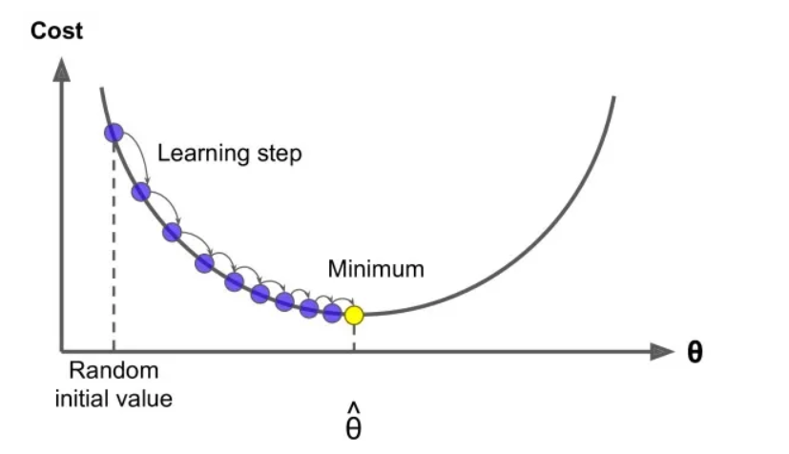
- An important parameter in Gradient Descent is the size of the steps, determined by the learning rate hyperparameter. If the learning rate is too small, then the algorithm will have to go through many iterations to converge, which will take a long time.
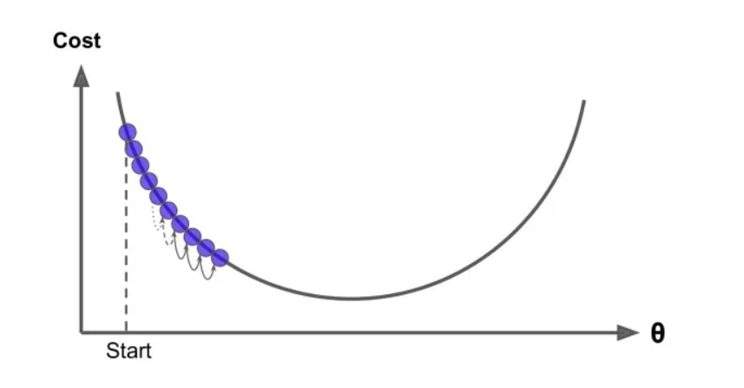
- On the other hand, if the learning rate is too high. This might make the algorithm diverge, with larger and larger values, failing to find a good solution.
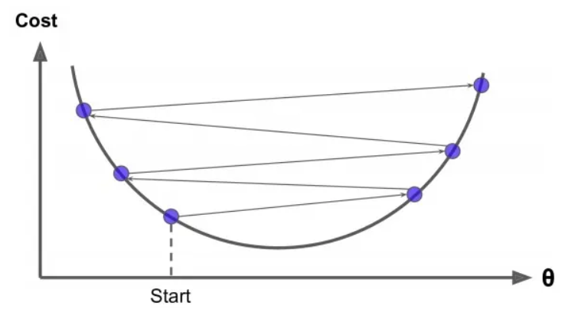
The two main challenges with Gradient Descent are:
1)If the random initialization starts the algorithm on the left, then it will converge to a local minimum, which is not as good as the global minimum.
2)If it starts on the right, then it will take a very long time to cross the plateau, and if we stop too early we will never reach the global minimum.
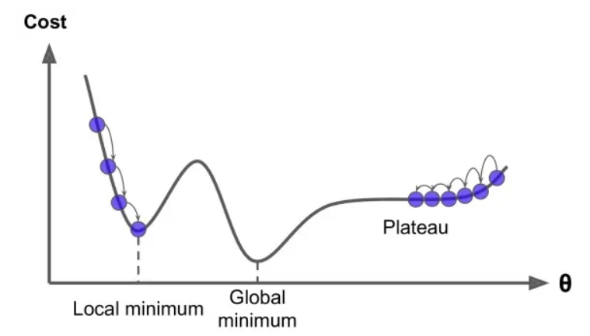
Advantage:
The goal of any ML model is to find parameters $θ$(weights) that give the minimum error.
Instead of trying all possible values, gradient descent:
- Starts with random parameters
- Gradually improves them step by step
- Moves toward optimal values

Types of Gradient Descent:
I) Batch Gradient Descent
II) Stochastic Gradient Descent

Batch Gradient Descent
It is variant of the gradient descent algorithm where the entire dataset is used to compute the gradient of the loss function with respect to the parameters.
In each iteration the algorithm calculates the average gradient of the loss function for all the training examples and updates the model parameters accordingly.
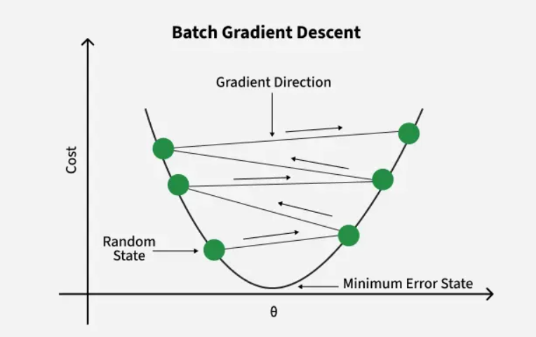

The update rule for batch gradient descent is:
θ=θ−η∇J(θ)
where:
- $θ$ represents the parameters of the model
- $η$ is the learning rate
- $∇J(θ)$ is the gradient of the loss function $J(θ))$ with respect to $θ$.
Algorithm Steps
- Initialize $θ$
- Compute cost using all samples
- Compute gradient from all samples
- Update $θ$
- Repeat
Advantages
- Stable Convergence: Since the gradient is averaged over all training examples the updates are less noisy and more stable.
- Global View: It considers the entire dataset for each update providing a global perspective of the loss landscape.

Disadvantages
- Computationally Expensive: It Processing the entire dataset in each iteration can be slow and resource-intensive especially for large datasets.
- Memory Intensive: This requires storing and processing the entire dataset in memory which can be impractical for very large datasets.

STOCHASTIC GRADIENT DESCENT
It is a variant of the gradient descent algorithm where the model parameters are updated using the gradient of the loss function with respect to a single training example at each iteration.
Unlike batch gradient descent which uses the entire dataset SGD updates the parameters more frequently, leading to faster convergence.
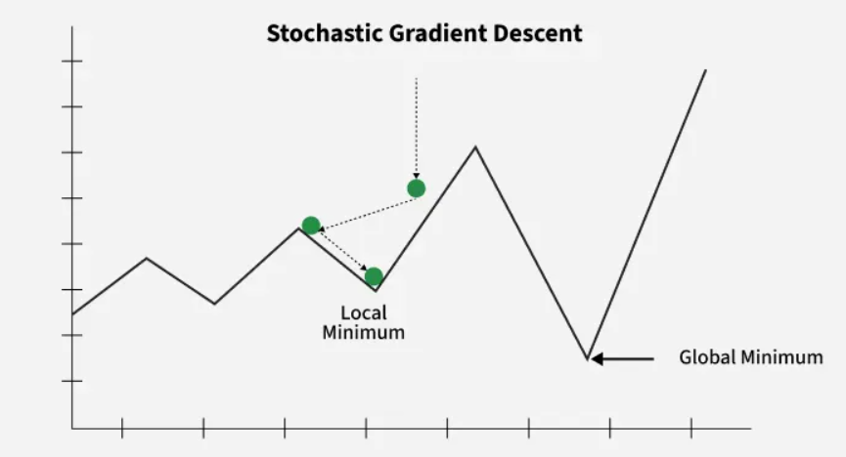
The update rule for SGD is:
θ=θ−η∇J(θ;x(i),y(i))
where:
- $θ$ represents the parameters of the model,
- $η$is the learning rate,
- $∇J(θ;x^{\left(i\right)},y^{\left(i\right)})$ is the gradient of the loss function$J(θ)$ with respect to $θ$ for the $i^{th}$ training example $\left(x^{\left(i\right)} , y^{\left(i\right)}\right)$
Algorithm Steps
- Initialize $θ$
- Shuffle dataset
- For each sample:
  - compute gradient using that sample
  - update $θ$
- Repeat for all epochs
Advantages
- Faster Convergence: Frequent updates can lead to faster convergence, especially in large datasets.
- Less Memory Intensive: Since it processes one training example at a time, it requires less memory compared to batch gradient descent.
- Better for Online Learning: Suitable for scenarios where data comes in a stream, allowing the model to be updated continuously.
Disadvantages
- Noisy Updates: Updates can be noisy, leading to a more erratic convergence path.
- Potential for Overshooting: The frequent updates can cause the algorithm to overshoot the minimum, especially with a high learning rate.
- Hyperparameter Sensitivity: Requires careful tuning of the learning rate to ensure stable and efficient convergence.

Mini-Batch Gradient Descent
It is a compromise between Batch Gradient Descent and Stochastic Gradient Descent.
Mini-Batch Gradient Descent is an optimization algorithm that updates model parameters using a small subset (batch) of training samples instead of using:
- the entire dataset (Batch GD)
- a single sample (Stochastic GD)
It combines the advantages of both methods.
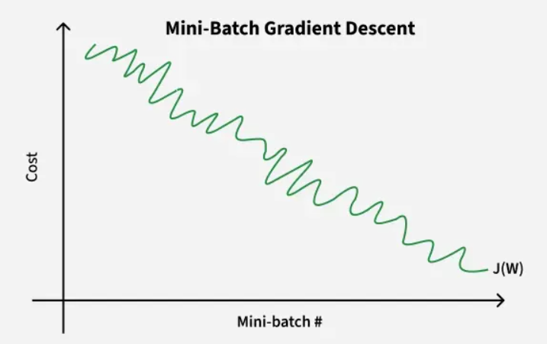
Update rule for Mini-Batch Gradient Descent is:
θ=θ−η∇J(θ;{x(i),y(i)}i=1m​)
where:
- $θ$ represents the parameters of the model,
- $η$is the learning rate,
- $\left\{x^{\left(i\right)} , y^{\left(i\right)}\}_{i=1}^{m}\right.$represents a mini-batch of m training examples,
- $∇J(θ;\{x^{\left(i\right)},y^{\left(i\right)}\}_{i=1}^{m})$ is the gradient of the loss function $J(θ)$ with respect to θ for the mini-batch.
How it Works
Instead of one update per epoch:
- Divide dataset into small batches
- Perform update after each batch
Typical Batch Size
Common choices:
- 16
- 32
- 64
- 128
Batch size is a hyperparameter.
Mini-Batch Gradient Descent Algorithm
- Initialize parameters $θ$randomly and choose learning rate $α$and mini-batch size $b$.
- Shuffle the training data to avoid bias in updates.
- Divide the dataset into small mini-batches of size $b$.
- For each mini-batch, compute the gradient of the cost function with respect to $θ$.
- Update parameters using:
$$θ:=θ-α⋅\text{gradient}$$
- Repeat for all mini-batches and epochs until convergence.
Advantages
- Faster Convergence: By using mini-batches, it achieves a balance between the noisy updates of SGD and the stable updates of Batch Gradient Descent, often leading to faster convergence.
- Reduced Memory Usage: Requires less memory than Batch Gradient Descent as it only needs to store a mini-batch at a time.
- Efficient Computation: Allows for efficient use of hardware optimizations and parallel processing, making it suitable for large datasets.
Disadvantages
- Complexity in Tuning: Requires careful tuning of the mini-batch size and learning rate to ensure optimal performance.
- Less Stable than Batch GD: While more stable than SGD, it can still be less stable than Batch Gradient Descent, especially if the mini-batch size is too small.
- Potential for Suboptimal Mini-Batch Sizes: Selecting an inappropriate mini-batch size can lead to suboptimal performance and convergence issues.

